February 2021
LO: to count in 2s
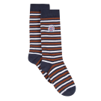

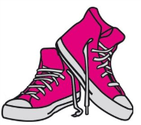
There are _____ pairs of socks. There are _____ socks altogether.
There are _____ pairs of shoes. There are _____ shoes altogether.


There are _____ pairs of gloves. There are ____ gloves altogether.


There are ___ pairs of flowers. There are ___ flowers altogether.
Reasoning – Jess is counting in 2s from 30. Will she say the number 39? How do you know?
__________________________________________________________________________________

