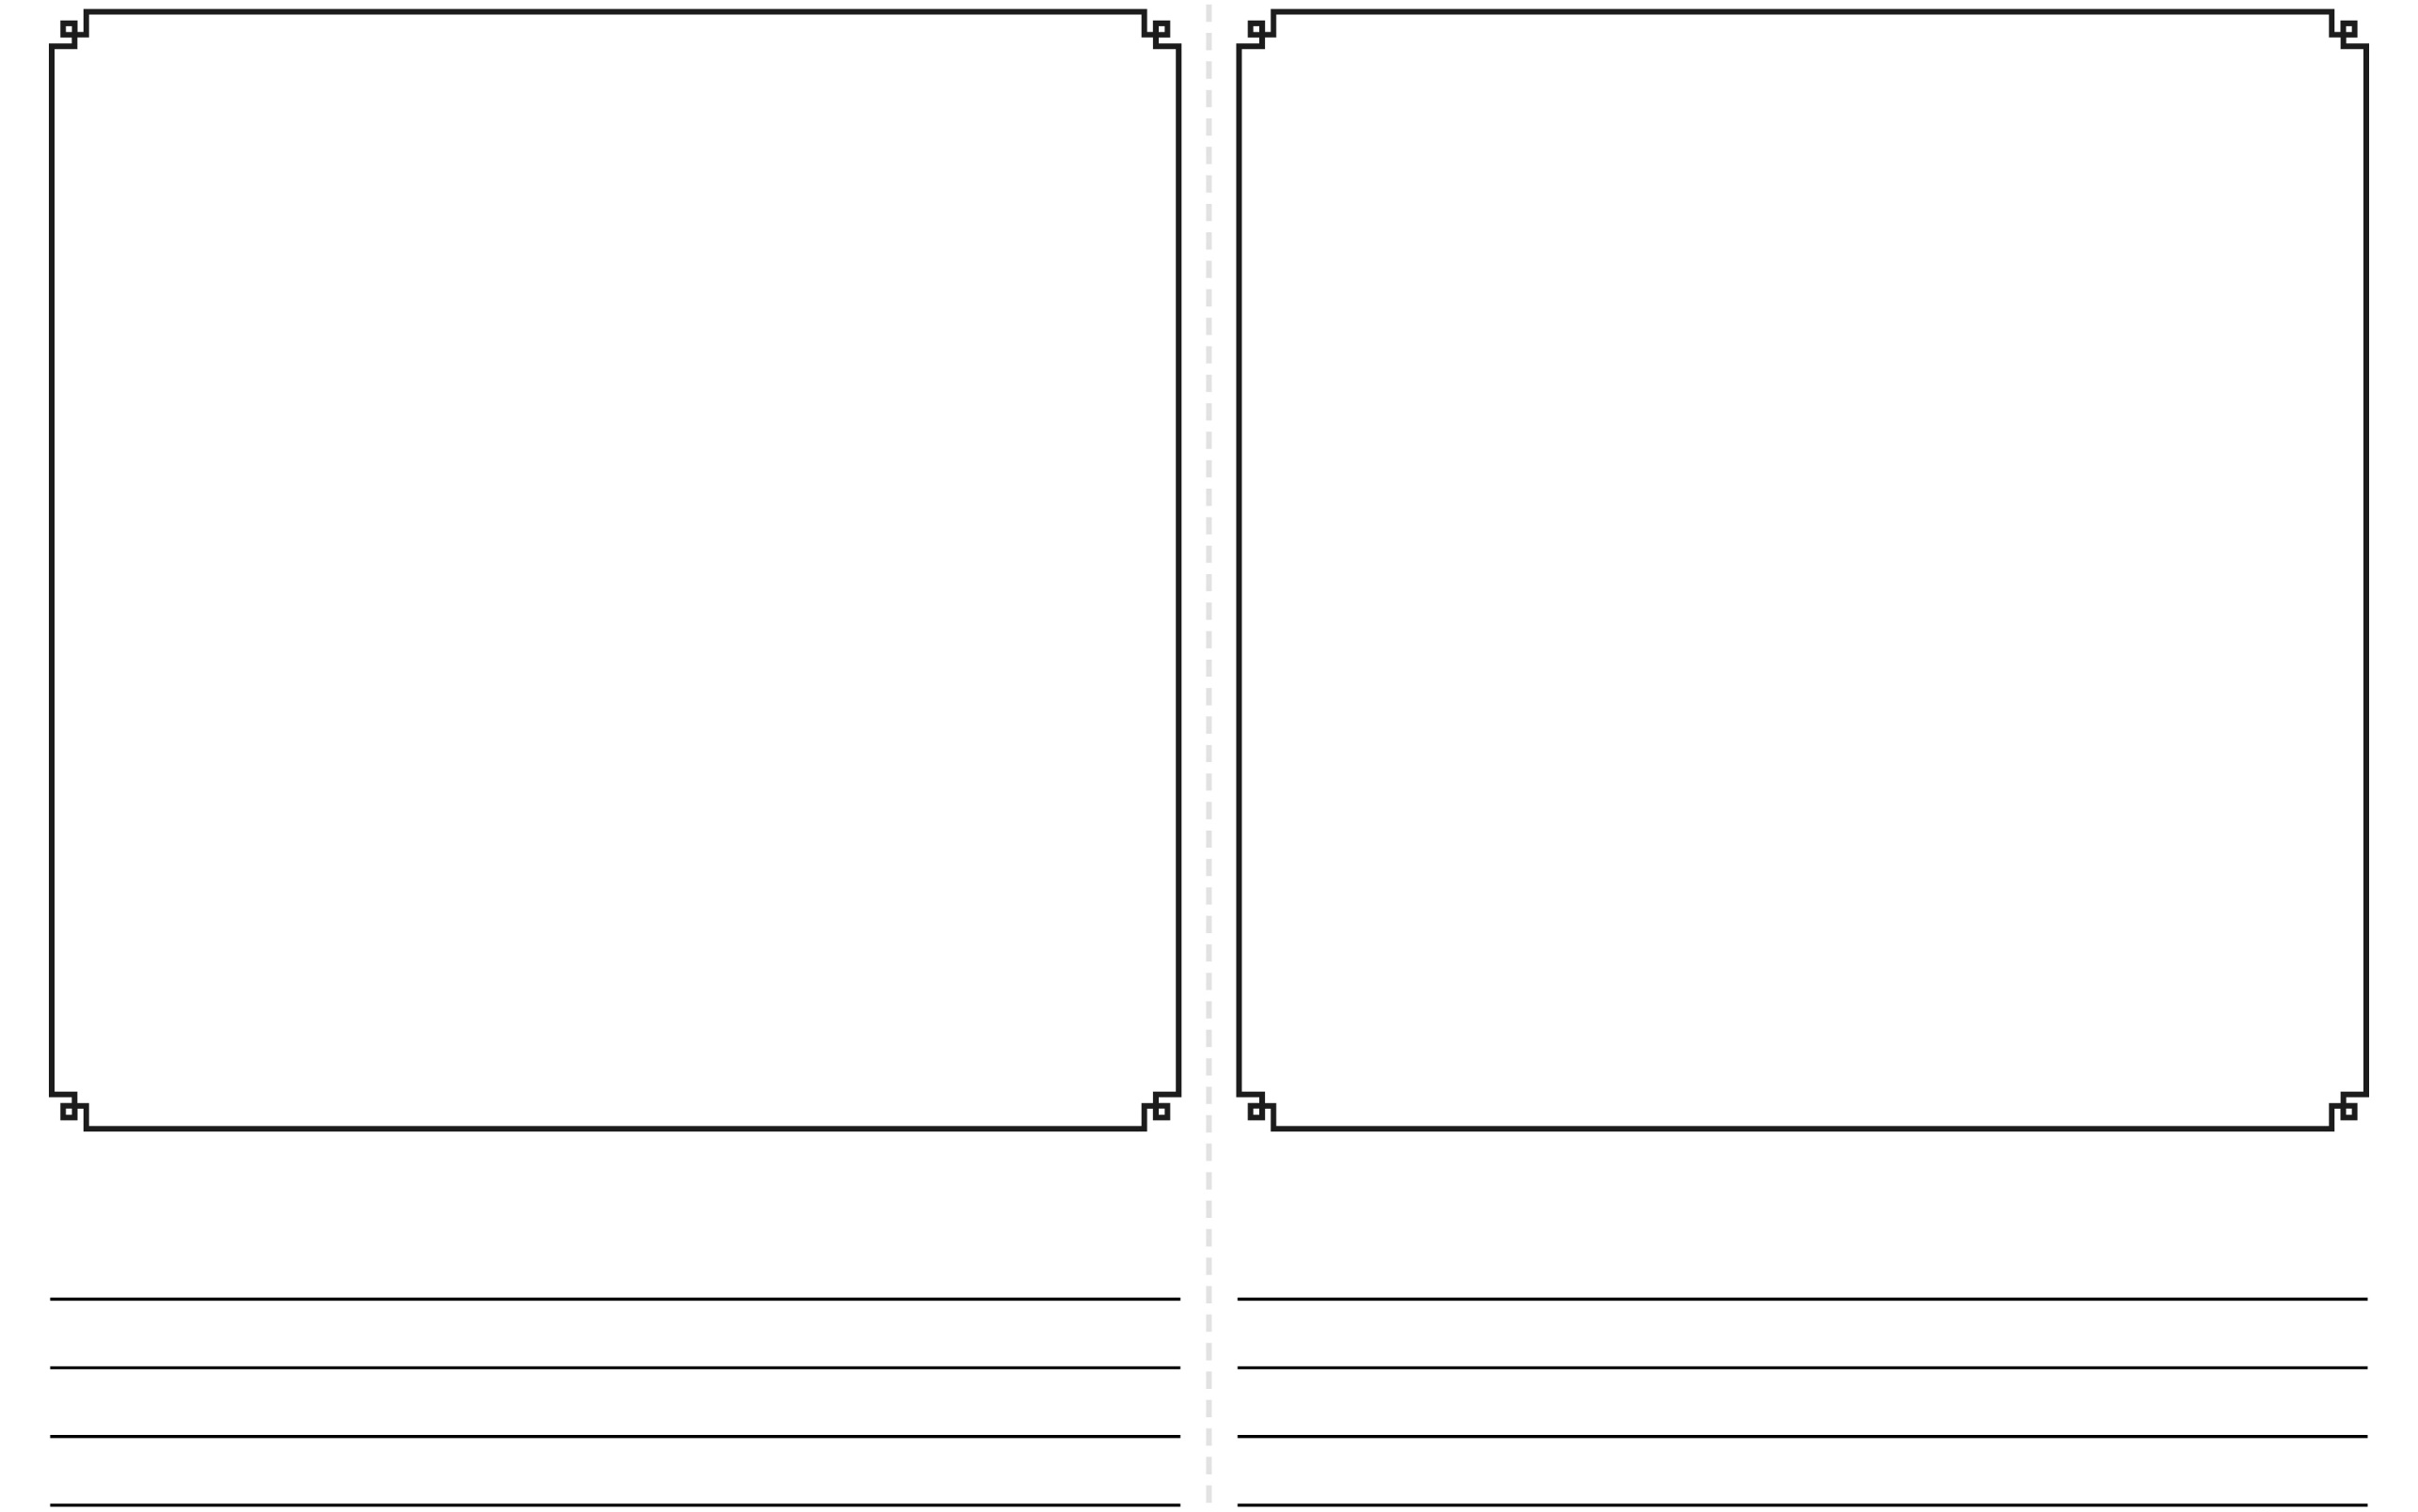
Draw a picture of your plant:
My Plant: Week 1
My Plant: Week 2
My plant is ____ cm tall.
My plant is ____ cm tall.
My Plant: Week 4
My Plant: Week 3
My plant is ____ cm tall.
My plant is ____ cm tall.

My Plant: Week 6
My Plant: Week 5
My plant is ____ cm tall.
My plant is ____ cm tall.

