February 2021
LO: to know England has been ruled by Kings and Queens for many years

Label the picture of Queen with – Crown, septure, throne, Sovereign's Orb, ring

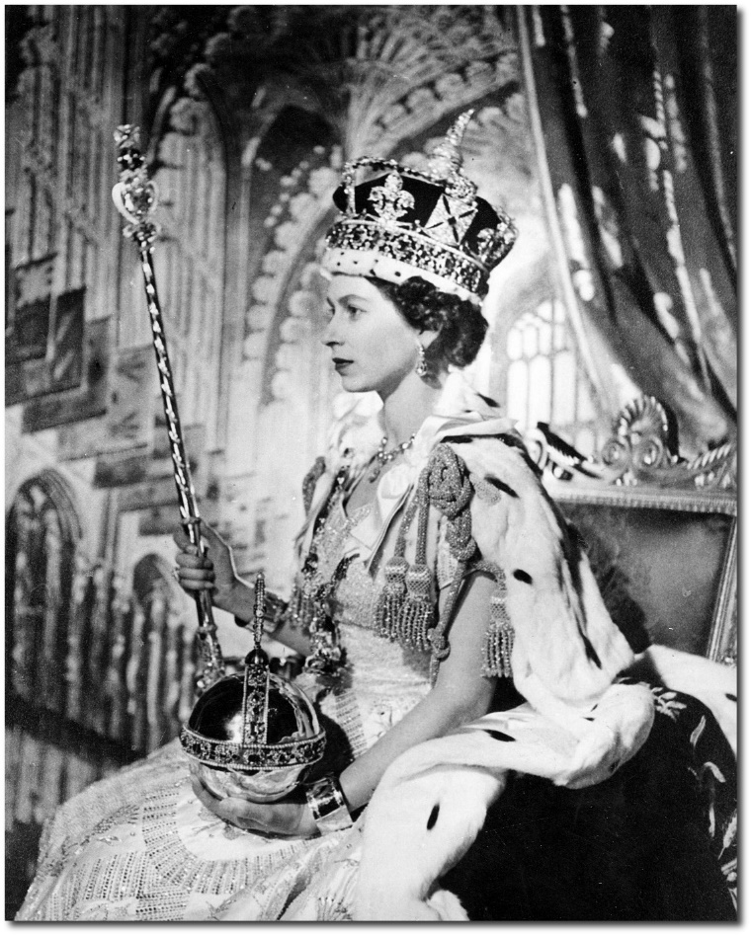
Who is our current ruler?
___________________________________________________________
How old was the Queen when she became Queen? ______________________

Write a sentence about what you have learnt:
_________________________________________________________________________________________________________________________________________________________________________________

