LO: to know about and analyse a famous piece of art work
Look at the picture below by William Hogarth painted this picture. It is called ‘The Graham Children’
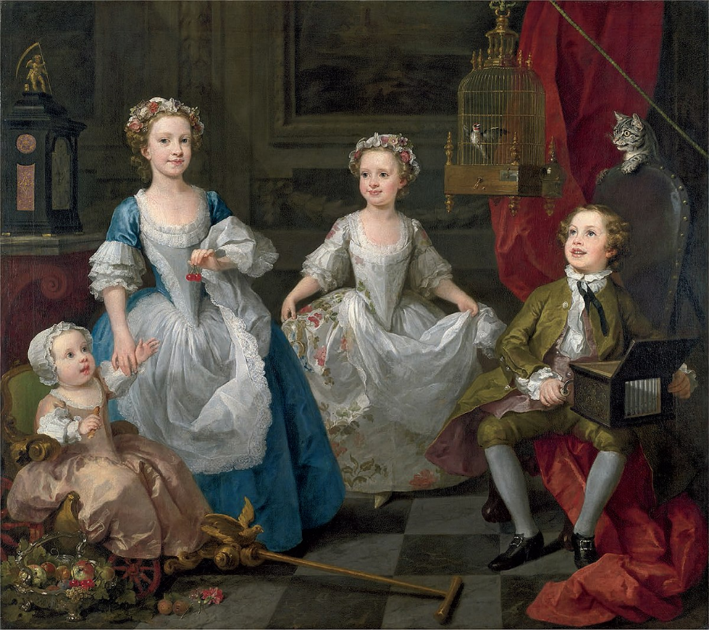
Write down what you can see in the picture you can use adjectives to help you.

