St Thomas More Catholic Primary School
Year 1 Home Learning Overview – Spring 1 - Week 5
Here is what we would like you to do over the next week! You will have an English task, a phonics task, a maths task, an RE task and a topic related task each day.
Don’t forget to practice your letter and number formation daily and read a range of books with your grown up.
 | Monday | Tuesday |  |  | Wednesday |  |  | Thursday |  | Friday
Message to you all | Year 1 Message Week 5 — Watch Video  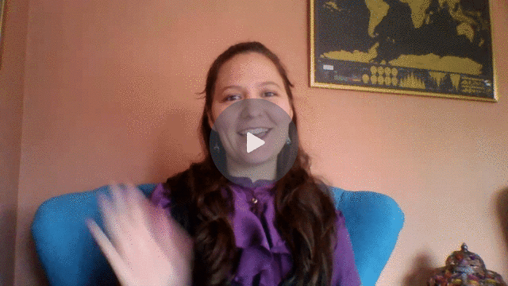
Reading/  Phonics | Sounds of the Week: u – fun, u – unicorn, ow – cow, ow – show,  Common Exception Words of the Week:  Use the sound mats to practise recognising and saying the phase 3, 4 and 5 sounds.  An electronic mat of the sounds has been added to the blended learning folder for you to use.  Practise reading and writing the common exception words of the week.  Think of and write sentences using the common exception words of the week.  Please use active learn primary to read your book daily.
Reading/  Phonics | DfE online Letters and sounds lessons: https://lettersandsounds.org.uk/for-home/year-1  Alphablocks: https://www.bbc.co.uk/cbeebies/shows/alphablocks  Phonics Play: https://www.phonicsplay.co.uk/  Phonics Bloom: https://www.phonicsbloom.com/
English | LO: to create a story map  Listen to the Talk for Writing story.  Draw a story map (see examples). Make sure there are pictures of the main events. Add vocabulary to support your pictures. Retell your story map to someone to show you know the story. |  | LO: write your own beginning  See PPT (modelled version) – We are going to start write our own version of the story Town Mouse, Country Mouse. Remember to include adjectives, finger spaces, capital letters at the start of sentences, full stops and re-read what you have written to make sure it makes sense. |  |  | LO: write your own middle  See PPT (modelled version) – Now we are writing the middle of the story. See the PPT to help with the structure and adjectives. Remember to include adjectives, finger spaces, capital letters at the start of sentences, full stops and re-read what you have written to make sure it makes sense. | LO: write your own ending  See PPT (modelled version) – Now we are writing the end of the story. See the PPT to help with the structure and adjectives. Remember to include adjectives, finger spaces, capital letters at the start of sentences, full stops and re-read what you have written to make sure it makes sense. |  | LO: handwriting  In your neatest handwriting copy the sentence and poem (see PPT) and include the correct punctuation.
English | Link to Town Mouse, Country Mouse story: https://www.youtube.com/watch?v=VviLjDO6D1U  Can you practise writing the letters of the alphabet in your neatest handwriting each day. Remember to start the letters on the line.
Maths | Go to the White Rose home learning page. There are daily videos explaining the learning.  Spring – week 5 – videos on subtraction (Monday, Tuesday and Thursday) https://whiterosemaths.com/homelearning/year-1/
Maths | Numbers to 50 using tens frames  See Video link – Counting to 50 by making 10. https://vimeo.com/500465193  Follow the PPT instructions. They understand what a ten frame is and how when it is full it makes 10. Then need to know how to count in 10’s (this will also help with their learning of the 10 times table) Answer the questions. |  | Numbers to 50  Video link – numbers to 50.  https://vimeo.com/500466597  Practise counting in 10s to 50. Look at the questions provided then answer the questions. |  |  | 1 more 1 less  Play a game – say a number and get the child to say one more. Play again but this time the child says one less. Once they have practised this verbally try with objects. Then they can fill in the grid for one more one less. | Tens and ones  https://vimeo.com/500467998  See PPT to help you. The children need to know that 12 is made up of 1 ten and 2 ones or 12 ones. This can be shown using straws bundled together or den sticks/cubes. The pictures can be used to support and help with their learning.  Use part whole models to partition the numbers into tens and ones. |  | Compare amounts  Using the PPT to help you Continue to practise comparing amounts (you can use practical equipment). Also you can use the link below to Hit the Button. See if you can beat your scores on addition and number bonds to 10 and 20.
Maths | Hit the Button: https://www.topmarks.co.uk/maths-games/hit-the-button  Numberblocks: https://www.bbc.co.uk/cbeebies/shows/numberblocks  Top Marks: https://www.topmarks.co.uk/Search.aspx?Subject=37&AgeGroup=1  Practise counting and number formation throughout the week.
Topic/other activities | RE  Forgiveness – importance of saying sorry  Read the story  Copy and complete the sentences -  I know that it is important to say sorry because...  I said sorry when ...  (you can draw a picture afterwards if you choose to)  Using the story think about what we do when someone says they are sorry. What would Jesus do if someone said sorry to him? |  | PHSE  This week in mental health week.  Talk to you children about how they are feeling. They can draw pictures if they would like to. See if anything is bothering them and if you have a solution to this. Tell them no feeling is a bad feeling we all feel these things.  Task – you are unique and special. They can write their name anyway they want and colour, paint, stick things on that shows their unique personality. They can also draw things around their name that makes them happy. |  |  | ART  Last week you create a piece of art using slat dough or other materials – if you have paint you can choose colours that will show that your piece of art comes from under the ocean. What colours would you need to use etc.  If you were unable to make your art piece – draw an underwater scene.  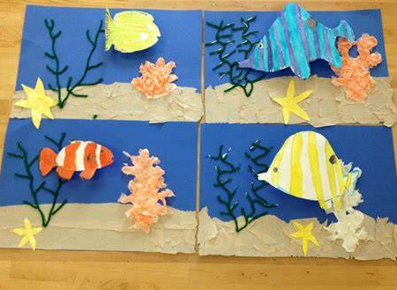  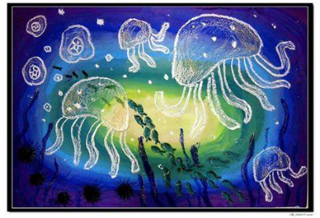 | Topic  This week we will be focusing on England. Look at the PowerPoint about England. Using the information and any other information you can find on the internet. Draw the English flag and flower and write a sentence about what you have learnt. Then using the PPT and any other information you have found out, write a postcard about a visit to a famous landmark. |  | SCIENCE  Our topic is weather. So far we have looked at how the seasons can affect the weather, weather stations and how people can measure the weather, snow and sunny days. This week we are looking at rain. Where does rain come from? How do the clouds form? What happens when it rains and it is sunny? Use the PPT to help you. Get the children to look at different clouds what is different? Draw a diagram of how
Topic/other activities | Music  LO; listen and respond to music.  See the PPT. Listen to the hall of the Mountain king. Draw a story map of Peer’s journey as he tiptoes and then runs through the mountains chased by the trolls.  Think about the dynamics of the music and label your story map with ‘p’ and ‘f’ as Peer runs along the path. |  |  | PE - Remember to get some daily exercise. We highly recommend the cosmic kids yoga (link below) as it offers the children the chance to listen to different stories and exercise. Yoga is also good for well-being.  Here are a few ideas of what you can do:  Run around the garden (Park) see how many times you can do it in 3 mins  Practise kicking a ball to each other.  Practise your balances – can you balance on one leg? Different positions?  Have a race, create an obstacle course.  Play just dance. Have a game of beans with the children. Play traffic lights.  PE Links  Just Dance Kids: https://www.youtube.com/results?search_query=just+dance+kids  Cosmic Kids Yoga: https://www.youtube.com/results?search_query=cosmic+kids+yoga  Wake Up Shake Up: https://www.youtube.com/watch?v=eD7zbsGjFo4

