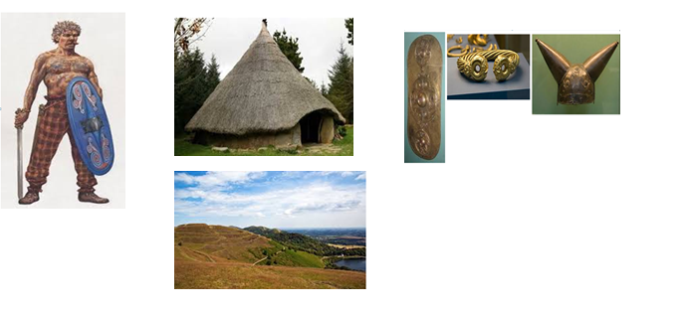
Tuesday 6th January 2020 LO: to know about the Celts life in the Iron Age
Celtic house – Celts lived in round houses with no windows. It was made of mud with a straw roof.
Helmet – Celts wore different shaped helmets with detailing on them.
Celtic man – Celts were fierce warriors, they painted their bodies blue. Their shields and helmets were made of iron. This is why it is called the Iron Age.
Forts – Celts liked to live in forts on tops of hills. This is because they could see attackers. You can still see some today.
Shield – Celts used shields to protect themselves when they fought.
Gold bracelet – Celts often wore jewelry

