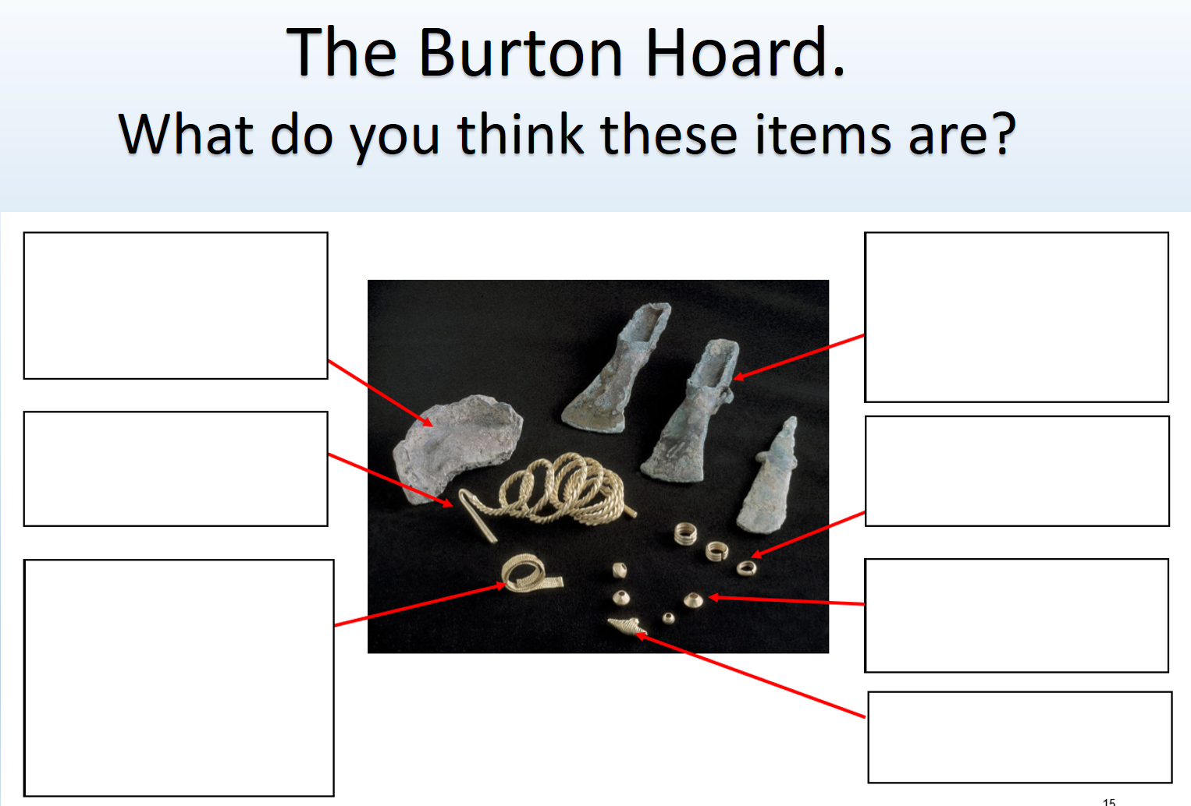

Ceramic Pot, Gold Torc, Gold Bracelet, Bronze Axe heads, Gold rings, Gold beads, Pendent

