02.10.2020
LO: Mini assessment

- Order the numbers smallest to greatest:
7 2 5 _________________
2 9 6 _________________
- 1 8 _________________
3 6 2 _________________
- Use the symbols < > =
6 1 3 8 2 7
- 3 8 8 4 5
- Order the numbers smallest to greatest:
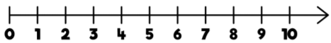
What is one less than 5?______________
What is one less than 3?______________
What is one more than 9?_____________
What is one more than 2?_____________
Circle the number 8.

