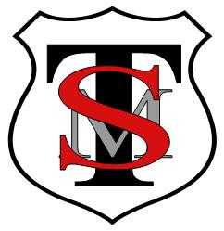
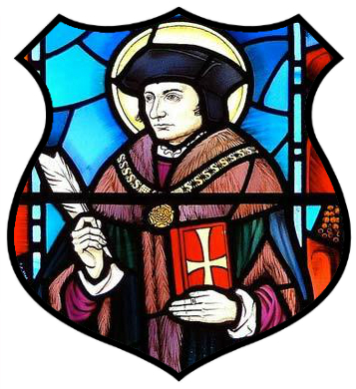
T: 0121 743 3289
E: enquiry@sttommor.bham.sch.uk
ST THOMAS MORE CATHOLIC PRIMARY SCHOOL
Horse Shoes Lane, Sheldon, Birmingham, B26 3HU
Principal: Mrs K Madia

Christ is the centre of our school community where we live, love and learn together.
www.sttommor.bham.sch.uk

Friday 27th May 2022

Dear Parent/Guardian

Anglo Saxon and Viking Workshop

There will be an anglo saxon workshop for years 2S, 1 / 2 and 1M

2S Morning of Thursday 9th June 2022

1 / 2 Afternoon of Thursday 9th June 2022

1M Morning of Friday 10th June 2022

There is a charge for this which is £9.36 per child.

Children can dress up in anglo saxon or viking costumes if they wish.

Regards

