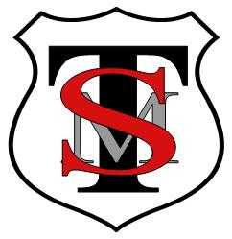
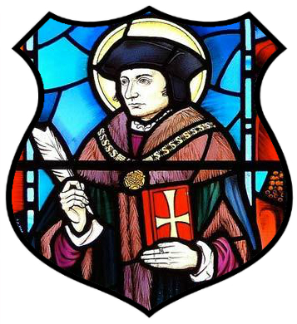
T: 0121 743 3289
E: enquiry@sttommor.bham.sch.uk
ST THOMAS MORE CATHOLIC PRIMARY SCHOOL
Horse Shoes Lane, Sheldon, Birmingham, B26 3HU
Principal: Mrs K Madia

Christ is the centre of our school community where we live, love and learn together.
www.sttommor.bham.sch.uk

Friday 27th May 2022

Dear Parent/Guardian

After School Clubs with Adam

emaining spaces are as follows:

Monday Multi Skills for Year 1, 2 & 3 has 6 spaces remaining.

Tuesday Football Club for Year 1 & 2 is now FULL.

Wednesday Football Club for Year 3, 4 & 5 has 6 spaces remaining.

Thursday Dodgeball Club for Year 5 & 6 has 9 spaces remaining.

Friday Dodgeball Club for Year 3 & 4 has 3 spaces remaining.

If you can communicate that out and please let me know when you have that would be amazing.

I’ve attached the link for parents to book again if you needed it.

