St Thomas More Home Learning Overview – Spring 2_Week 3.
08/03/2021 – this term we are being Attentive and Discerning.
Here is what we would like you to do over the next week! The Key outcome – understand writing the plot, with use of dialogue.
You will have an English task, a mathematical task and another subject related task each day. Don’t forget to practice your times tables and spellings.
 | Monday 8th March | Tuesday 9th March |  | Wednesday 10th March |  |  | Thursday 11th March |  |  |  | Friday 12th March
English  Extra Challenge –  How many synonyms can you find for SAID? | Writing  Practice your handwriting – take a page from a book or magazine and copy it out. Write the alphabet out in upper and lower case.  LO – to add the prefix –bi and re  Bicycle  Biplane  Bisect  Bilingual  Biannual  Reappear  Redecorate  Reapply  Prepay  Rebuild  Complete your handwriting taks. | Reading  LO – to read a story aloud  Read the introduction up to ‘But there is one thing that scares me more than anything else...’  What do you think that fear is? Record thoughts pictorially with captions.  Look for clues in the book. Read aloud the story from the beginning, revealing his fear of the dark until ‘I hate bedtime.’  Look closely at Orion’s failed solutions, do any of these match the advice that you gave Orion?  Do they look similar to their own solutions for him?  Why do you think they didn’t work?  What do you think of Orion now?  Create a new image of Orion. |  | Writing  LO – to write dialogue  Revisit the image of Orion at the foot of his staircase at bedtime., look closely and think of three things that you notice about the illustration, using commas in a list, write them down.  How does this image make us feel? Why?  What do you like or dislike about it?  Does anything puzzle you about what is happening or what you see?  Does it remind you of anything in real life or in stories?  Write your ideas around the image of Orion. You should create an image with vocabulary relating to fears of the dark, mood and atmosphere.  What do you think mum is doing as she calls, “Goodnight Orion.” And how Orion feels as he calls, “Goodnight Mum”.  You will need to write dialogue between Mom and Orion – usinf inverted commas of speech bubbles. |  |  | 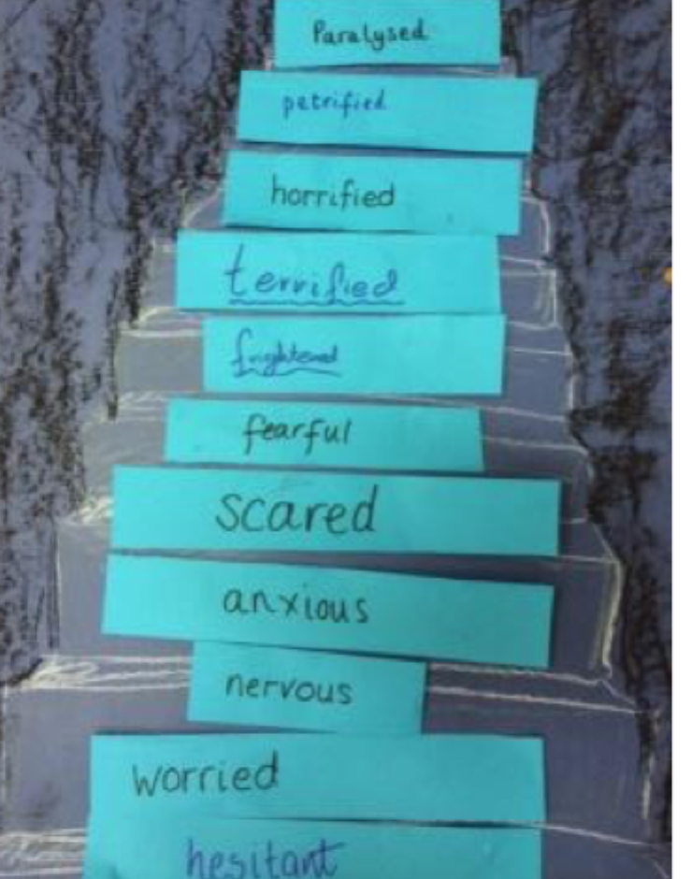  Writing  LO – to order words according to shade of intensity.  Did you know that Inuit people have over 300 words for snow? Why do you think that is? Although there may be many different words for the same thing, there are usually slight differences in meaning. For example, ‘cross’ and ‘furious’ both mean angry, but ‘furious’ means more angry than ‘cross’ does.  Look at the image of the staircase, with Orion’s dark bedroom door at the top. Write the word SCARED on the middle step. Think about how Orion is feeling as he going to bed, as moves further up the stairs, closer to his dark bedroom. On each step, write a different word relating to how Orion is feeling – stronger than scared eg ‘frightened’, ‘petrified’... |  |  |  | Reading  LO – to answer comprehension questions  Read the text about Mother’s Day and answer the questions.
Please remember to do some reading each day- try reading from different sources such as newspapers, magazines etc
You could put the sub titles on the television and turn the sound down. Look at POBBLE 365 and complete some of the tasks. Also remember the access Spelling Shed.

Mathematics | LO – to add length  https://vimeo.com/506146810  As it’s World Book Day, learn about measuring books and adding the measurements together. | LO – to subtract length  https://vimeo.com/506146876 |  |  | LO – to explore perimter  https://vimeo.com/507042543 |  | LO – to measure perimeter  https://vimeo.com/507043505 |  | LO – to calculate perimeter  https://vimeo.com/508441217
Mathematics | Watch the video, stopping to complete questions as you go  Visit: https://whiterosemaths.com/homelearning/year-3/spring-week-4-measurement-money/  YOU WILL ALSO NEED TO BE A TIMESTABLE ROCKSTAR
Wider Curriculum | RE  LO – to know that Lent is a special season when Christians pray for forgiveness and try to change to become more like Jesus.  Lenten symbols: https://www.youtube.com/watch?app=desktop&v=MX4HcWGD_Rc  Lent Explained: https://www.youtube.com/watch?v=ukIBEWtlqDg  Write your Lenten prayer on the foorprint |  | History  LO – to find out about Richard III, and the Princes in the Tower of London  Why did Richard III become King? ​He claimed that Edward IV's marriage to Elizabeth Woodville was not a proper marriage, and that this meant Edward V could not be king. Parliament then passed a law that agreed with this. He was crowned as Richard III on 3 July. ichard have wanted to kill the Princes? ​  What evidence suggests that Richard III did not kill the Princes in the Tower?  Debate who was responsible for the death of the Princes. |  |  | RE  LO – to understand the meaning of receiving ashes on Ash Wednesday.  Go through the PPT and write your explanation about he ashes |  | Geography  LO – to know about the Amazon River.  What do you know about the Amazon River?  Why is The Amazon Rainforest is one of the wettest parts of the world?  It is almost always raining.​  The air feels sticky because of all the water.​ |  | Music  LO – to know that a musical rest is a symbol used in music to represent silence.
Wider Curriculum | PSHE  LO – to think positively  Follow the ppt and think about how you have been thinking positively recently. |  | Science  LO – to know that some objects produce light energy and that these are light sources |  |  | PSHE  Well-Being Wednesday  LO – to know about expressing thoughts, feelings and emotions. |  | PE  With Adam |  | PE  Teacher PE / Forest School.

