Big Ben
(Houses of Parliament
In London)
Angel of the North
(Gateshead)
Clifton Suspension Bridge
(Bristol)
Wembley Stadium
(London)
Edinburgh Castle
(Scotland)
RIVER SEVERN
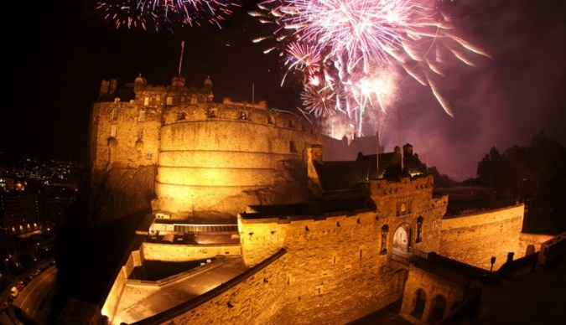
(longest river in UK)
Ben Nevis
(Highest mountain in UK)
Forest of Dean
(In Gloucestershire)
Durdle Door
(Jurassic Coast)
Lake Windermere
(Largest lake in England)


