STIG OF THE DUMP, by Clive King

He was lying in a kind of shelter. Looking up he could see a roof, or part of a roof, made of elder branches, a very rotten old carpet and rusty old sheets of iron. There was a big hole through which he must have fallen. He could see the white walls of the cliff, the trees and creepers at the top and the sky with clouds passing over it.

It was dark in this den. It seemed to be partly a cave dug into the chalk, partly a shelter built out over the mouth of the cave. Woodlice and earwigs dropped from the roof where he had broken through it.

Barney had never seen anything like the collection of bits and pieces, odds and end, that this Stig creature had lying about his den. There were stones and bones, fossils and bottles, skins and tins, stacks of sticks and hanks of string. There were motor-car tyres and hats from old scarecrows, nuts and bolts and bobbles from brass bedsteads. There was a coal scuttle full of dead electric light bulbs and a basin with rusty screws and nails in it. There was a pile of bracken and newspapers that looked as if it were used for a bed. The place looked as if it had never been given a tidy-up.

Where the water dripped through a crack in the rood of the cave Stig had wedged the mud-guard of a bicycle. There water ran along this, through the tube of a vacuum cleaner and into a big can with writing on it. By the side of this was a plastic football carefully cut in half and Stig dipped up some water and offered it to Barney.

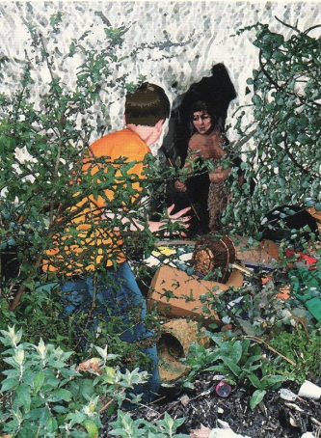
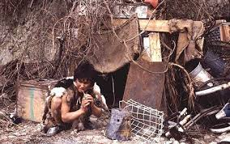
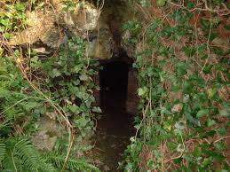
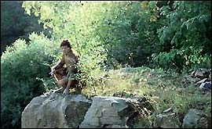
It was dark in the back of the cave. Stig went to the front where the ashes of a fire were smoking faintly, blew on them, picked up a book that lay beside his bed, tore out a page and rolled it up, lit it at the fire and carried it to a lamp set in a niche in the wall. As it flared up Barney could see it was in fact an old teapot, filled with some kind of oil.

STIG OF THE DUMP by Clive King
- Name two items that the roof was made from.
- What could Barney see through the hole in the roof?
- Along with woodlice, what else dropped from the ceiling in the den?
- What kind of rock was the cave made from?
- List at least five objects that Barney could see in Stig’s cave.
- What had Stig made his bed from?
- What did Stig collect water in from the dripping roof?
- Where had Stig made his fire?
- What did Stig use to light a flame so that he could light his lamp?
- What was Stig’s lamp made from?
- Would you like to live in Stig’s cave? Explain your answer.

STIG OF THE DUMP, by Clive King

He was lying in a kind of shelter. Looking up he could see a roof, or part of a roof, made of branches, a very rotten old carpet and rusty old sheets of iron. There was a big hole through which he must have fallen. Through the hole he could see the trees and the sky with clouds passing over it.

It was dark in this den. Woodlice and earwigs dropped from the roof where he had broken through it.

Barney had never seen anything like the collection of bits and pieces, odds and end, that this Stig creature had lying about his den. There were stones and bones, fossils and bottles, skins and tins, stacks of sticks and hanks of string. There were motor-car tyres and hats from old scarecrows, nuts and bolts and bobbles from brass bedsteads. There was a coal scuttle full of dead electric light bulbs and a basin with rusty screws and nails in it. There was a pile of bracken and newspapers that looked as if it were used for a bed. The place looked as if it had never been given a tidy-up.

STIG OF THE DUMP by Clive King
- What did Barney find himself lying in?
- The roof was made from branches, a …………………………..
- What could Barney see through the hole in the roof?
- Woodlice and …………………. dropped from the roof where he had broken through it.
- List three objects that Barney could see in the cave.
- What did Stig use for his bed?
- Do you think Stig’s cave was tidy or untidy? Explain your answer.
- Would you like to live in Stig’s cave? Explain your answer.

