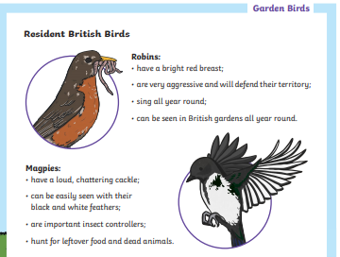
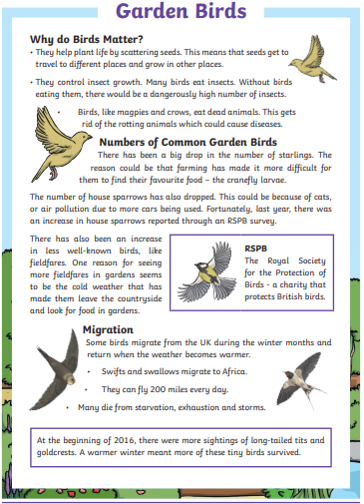
Question
1 – Why is it a good thing that birds scatter seeds?
2 – What would happen if birds did not eat insects?
3 – Name one bird that eats dead animals?
4 – What’s a starlings favourite food?
5 –Give one reason why there are fewer house sparrows.
6 – What do the RSPB do?
7 – Why are fieldfares having to leave the countryside?
8 – How far can migrating birds fly in one day?
9 – Which word has been used that means robins can get angry with other birds?
10 – Write two facts about magpies.

